**IIT MANDI CS-207 APPLIED DATABASE PRACTICUM MONSOON 2022**

**ASSIGNMENT 1: Understanding HTML and CSS**

**(In group of 6 students)**

**Dr. Varun Dutt Due: Before 1 PM on August 17, 2022**

**Readings:**

* Class notes and slides from week 1
* Activity 1 on Moodle

**Objectives:**

* + Understand how HTML and CSS tags.
  + Understand how to create webpages.

**Submission:**

Please submit as a zipped file, the following documents with your group number: o HTML file and CSS stylesheet with proper filenames

o Any supplementary material that is required to run the HTML files (e.g., images, video, Audio)

**Assignment:**

Q1. Create a webpage similar to the one attached below using HTML, HTML5 and CSS.

The following things should be present in the webpage:

1. The webpage should contain a dropdown menu on the left which changes color when the mouse pointer hovers over it. (See:

https://[www.w3schools.com/bootstrap/tryit.asp?filename=trybs_ref_js_dropdown_multil](http://www.w3schools.com/bootstrap/tryit.asp?filename=trybs_ref_js_dropdown_multil) evel_css&stacked=h)

1. The webpage should contain a table in the format given below.
2. An Audio should be present in the webpage. (The audio file can be downloaded from Moodle).
3. The Webpage should also contain a slider for performing addition as shown in the image below. When we move the slider, the correct value should be shown. (You can see https://[www.w3schools.com/jsref/event_oninput.asp)](http://www.w3schools.com/jsref/event_oninput.asp))

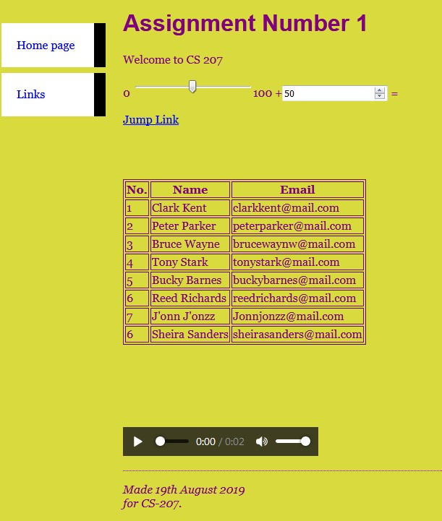

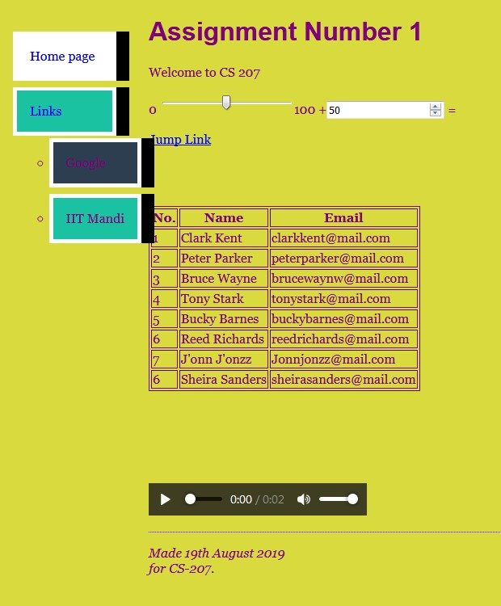

Q6. **[Optional Bonus]** When you click on the “Jump Link” (as shown the image below) it should take you to the end of the document.

